Back End – Assignments

JAVA ASSIGNMENTS
- Write a program to cover all Java OOPS concepts. Topics need to cover:

  - Class and Object
  - Class constructor
  - Method overloading
  - Method overriding
  - Inheritance
  - Interface
  - Abstract class
- Design a Java program that performs various string operations and uses control statements for user input validation. The program should allow the user to perform the following operations:

  - Extract Substring: The user can enter a string and specify the starting and ending index, and the program should extract and display the substring.
  - Split a Sentence: The user can enter a sentence, and the program should split it into words and display them.

- Design a Java program to implement a Collection Management System that manages different types of collections such as lists, sets, and maps. The program should allow users to perform the following operations for each type of collection:

  - Lists:
    - Add an element: The user can add an element to the list.
    - Remove an element: The user can remove an element from the list.
    - Display all elements: The user can view all elements in the list.
  - Sets:
    - Add an element: The user can add an element to the set.
    - Remove an element: The user can remove an element from the set.
    - Display all elements: The user can view all elements in the set.
    - Implement exception handling to handle possible errors (e.g., element not found in the list/set, duplicate keys in the map).
    - Provide a user-friendly console interface for the user to interact with the Collection Management System.

- Add new employees: The user can add details like employee ID, name, department, and salary.
  - Update employee details: The user can update the name, department, or salary of an existing employee based on their employee ID.
  - Delete an employee: The user can delete an employee from the system based on their employee ID.
  - Display all employees: The user can view a list of all employees and their details.
  - Search for an employee: The user can search for an employee by their employee ID and view their details.
  - Requirements:
    - Use Object-Oriented Programming (OOP) principles and create an Employee class with appropriate attributes and methods.
    - Use appropriate data structures (e.g., ArrayList, HashMap) to store the employee data.
    - Implement exception handling to handle possible errors (e.g., invalid employee ID, input validation).
    - Provide a user-friendly console interface for the user to interact with the Employee Management System.
JDBC ASSIGNMENTS
- Design a Java program to create a simple employee management system using JDBC and MySQL Connector/J. The program should allow users to perform the following operations:
  - Add a new employee: The user can enter details like employee ID, name, department, and salary, and the program should add the employee to the database.
  - Update employee details: The user can update the name, department, or salary of an existing employee based on their employee ID.
  - Delete an employee: The user can delete an employee from the database based on their employee ID.
  - Display all employees: The program should retrieve and display a list of all employees and their details from the database.
  - Requirements:
    - Use JDBC and MySQL Connector/J to connect to the MySQL database and perform CRUD (Create, Read, Update, Delete) operations.
    - Implement exception handling to handle possible errors during database interactions.
    - Provide a user-friendly console interface for the user to interact with the employee management system.
    - Cover Java topics such as classes, methods, user input and output (I/O), and exception handling.
  - Note: Before running the program, make sure you have MySQL installed, create a database named "employee_management," and a table named "employees" with columns: "id" (INT, PRIMARY KEY), "name" (VARCHAR), "department" (VARCHAR), and "salary" (DOUBLE).
SPRING BOOT ASSIGNMENTS
- Design a Spring Boot program to create a CRUD (Create, Read, Update, Delete) application using Hibernate for managing employee records. The program should allow users to perform the following operations on the employee database:

  - Add a new employee: The user can enter details like employee name, department, and salary, and the program should add the employee to the database.
  - Update employee details: The user can update the name, department, or salary of an existing employee based on their employee ID.
  - Delete an employee: The user can delete an employee from the database based on their employee ID.
  - Display all employees: The program should retrieve and display a list of all employees and their details from the database.
  - Requirements:
    - Use Spring Boot to create the application and Hibernate to manage the database.
    - Implement JPA (Java Persistence API) for data access.
    - Provide a RESTful API for performing CRUD operations on employees.
    - Implement exception handling to handle possible errors during database interactions.
    - Cover Spring Boot and Hibernate topics, such as entity classes, repositories, services, and controllers.
  - Note: Before running the program, make sure you have set up the database and configured the connection in the application.properties file.

SQL Assignment
Emp table :

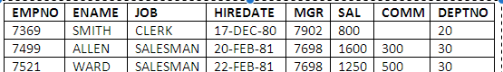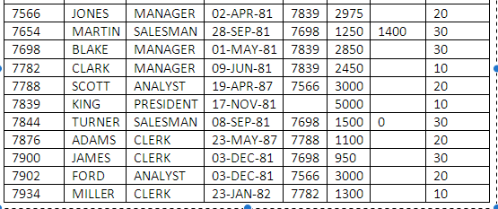

Dept :

Deptno | Dname | Loc
10 | Accounting | New york
20 | Research | Dallas
30 | Sales | Chicago
40 | Operations | Boston

7.Question
- Write a query to display ename and job for all the employee with their half term salary.
- Write a query to display all the details of the employees along with an annual bonus of 2000.
- Write a query to display ename and salary with a hike of 10%.
- Write a query to display ename and salary with deduction of 25%."
8.Question
- Write a query to display name and hire date of the employees if the employees were hired during 1982 .
- Write a query to display name of the employee who gets salary as well as commission .
- Write a query to display name of the employee of employee has character 'A' as the second character in the name .

9.Question
- Write a query to display avg salary needed to pay all the employees in each department excluding the employees of deptno 20.
- Write a query to display number of employees having character 'a' in their names in each job .
- Write a query to display maximum salaries given to an employee working in each dept
- Write a query to display ename and job of all the employees working in the same designation as james.
- Write a query to display ename and hiredate of the employees who's name end’s with 's' and hired after james ."

